SIMATS ENGINEERING
ASSESSMENT TOOL 2
COURSE NAME: Fundamentals Of Data Science COURSE CODE: DSA04
COURSE OUTCOME COVERED
CO3: Evaluate datasets using descriptive statistics, including summarization, outlier detection, and distribution analysis, and perform statistical inference through estimation and hypothesis testing. (BL3)
Assessment Tool Weightage: 20%
QUESTIONS: 02 Total Marks:100 Annexure A
Data Interpretation
Code of Conduct:
I Anto Chriswin G / 192324093 (Name / Reg No) certify that this submission is my original work and that I have adhered to the guidelines specified for this assessment.

I understand that any violation of academic integrity rules will result in disciplinary action.
Signature of the student:

RUBRICS FOR CALCULATION
Criteria | Weightage | Level  4 (Exemplary)  5 Marks | Level  3 (Proficient)  3 /4 Marks | Level  2 (Developing)  2 Marks | Level  1 (Beginning)  1 Mark | Marks
Understanding of Data | 25% | Accurately interprets all data patterns, trends, and relationships | Interprets data  correctly with  minor gaps | Partial  understanding;  misses key trends | Misinterprets or fails to  understand data
Analysis | 25% | Provides deep analysis with strong logical  reasoning and  justification | Provides  reasonable  analysis with some justification | Basic analysis  with weak  reasoning | No meaningful analysis  provided
Application of Concepts | 20% | Effectively applies  relevant concepts/tools to interpret data accurately | Applies concepts with minor errors | Limited  application;  requires guidance | Unable to apply concepts to data
Conclusion | 20% | Draws clear, meaningful conclusions with strong insights and implications | Provides valid  conclusions with moderate insights | Conclusions are  vague or weak | No clear or  valid  conclusions
Clarity | 10% | Presents interpretation clearly using proper  structure, visuals, and terminology | Generally clear  with minor issues | Lacks clarity or  proper structure | Poor  presentation and difficult to  understand

Annexure A
Problem 01: Hospital Patient Health Monitoring
Scenario
A hospital wants to investigate how patient lifestyle factors affect blood pressure levels. Dataset
Patient_ID | Daily_Exercise (Minutes) | BMI | Systolic_BP
P001 | 10 | 32 | 150
P002 | 15 | 31 | 148
P003 | 20 | 30 | 145
P004 | 25 | 29 | 142
P005 | 30 | 28 | 138
P006 | 35 | 27 | 134
P007 | 40 | 26 | 130
P008 | 45 | 25 | 126
P009 | 50 | 24 | 122
P010 | 55 | 23 | 118

Tasks
1. Find the mean and standard deviation of blood pressure.
2. Calculate covariance between:
o Exercise and Blood Pressure
o BMI and Blood Pressure
3. Calculate correlation coefficients.
4. Identify whether exercise or BMI is more strongly associated with blood pressure.
5. Discuss possible healthcare interventions.

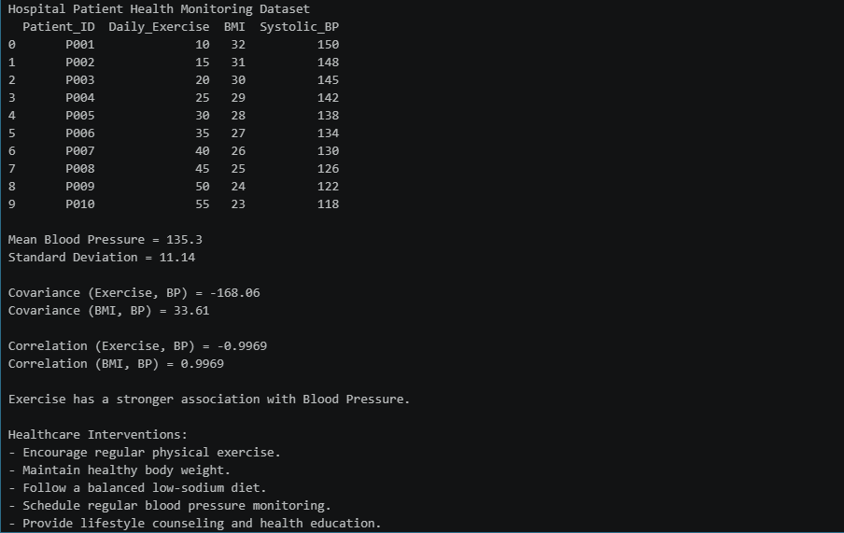

Problem 02: E-Commerce Customer Behaviour Analysis
Scenario
An e-commerce company wants to identify factors influencing customer spending. Dataset
Customer_ID | Website_Visits | Time_Spent (Minutes) | Purchase_Amount (₹)
C001 | 5 | 20 | 1200
C002 | 8 | 25 | 1800
C003 | 10 | 30 | 2500
C004 | 12 | 35 | 3200
C005 | 15 | 40 | 4000
C006 | 18 | 45 | 5000
C007 | 20 | 50 | 6200

C008 | 23 | 55 | 7300
C009 | 25 | 60 | 8500
C010 | 28 | 70 | 10000

Tasks
1. Calculate mean, variance, and standard deviation of Purchase Amount. 2. Find covariance between:
o Website Visits and Purchase Amount
o Time Spent and Purchase Amount
3. Calculate correlation coefficients.
4. Determine which customer behavior metric better predicts spending. 5. Suggest marketing strategies based on the findings.

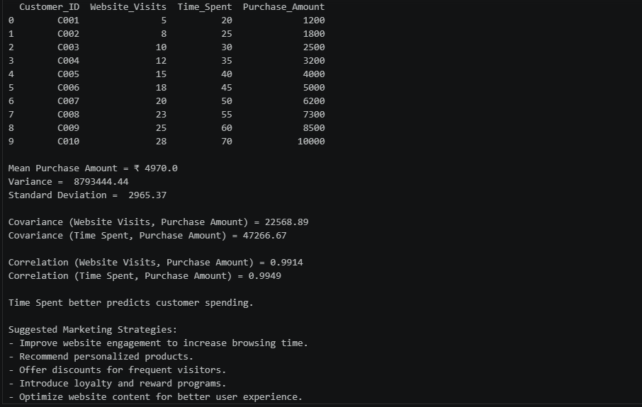

Problem 03: Employee Productivity and Performance
Scenario
A software company is investigating the relationship between employee productivity and performance ratings.
Dataset
Employee_ID | Training_Hours | Projects_Completed | Performance_Rating
E001 | 5 | 2 | 60
E002 | 8 | 3 | 65
E003 | 10 | 4 | 70
E004 | 12 | 5 | 74
E005 | 15 | 6 | 79
E006 | 18 | 7 | 84
E007 | 20 | 8 | 88
E008 | 22 | 9 | 91
E009 | 25 | 10 | 95
E010 | 28 | 11 | 98

Tasks
1. Compute the mean, variance, and standard deviation of Performance Ratings. 2. Calculate covariance between:
o Training Hours and Performance Rating
o Projects Completed and Performance Rating
3. Compute correlation coefficients.
4. Identify the strongest factor affecting employee performance.
5. Recommend HR policies to improve employee productivity

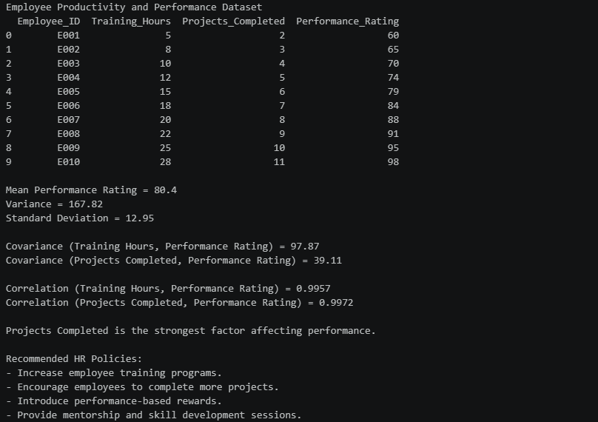

Problem 04 : Smart City Traffic Analysis
A city administration wants to analyze traffic congestion patterns.
Day | Traffic_Volume  (Vehicles) | Rainfall  (mm) | Average_Speed  (km/h) | Accident_Count
D1 | 12000 | 0 | 55 | 2
D2 | 13500 | 5 | 50 | 3
D3 | 14500 | 10 | 48 | 4
D4 | 16000 | 15 | 45 | 5
D5 | 17500 | 20 | 42 | 6
D6 | 19000 | 25 | 38 | 8
D7 | 21000 | 30 | 35 | 10
D8 | 22500 | 35 | 32 | 12
D9 | 24000 | 40 | 28 | 14
D10 | 26000 | 45 | 25 | 16

Tasks
1. Calculate descriptive statistics (Mean, Variance, Standard Deviation) for all variables. 2. Compute covariance matrices.
3. Compute correlation matrices.
4. Identify positive and negative relationships among variables.
5. Determine which factor is most associated with accident occurrence. 6. Provide data-driven recommendations to reduce traffic accidents.
7. Visualize relationships using scatter plots and interpret the results.
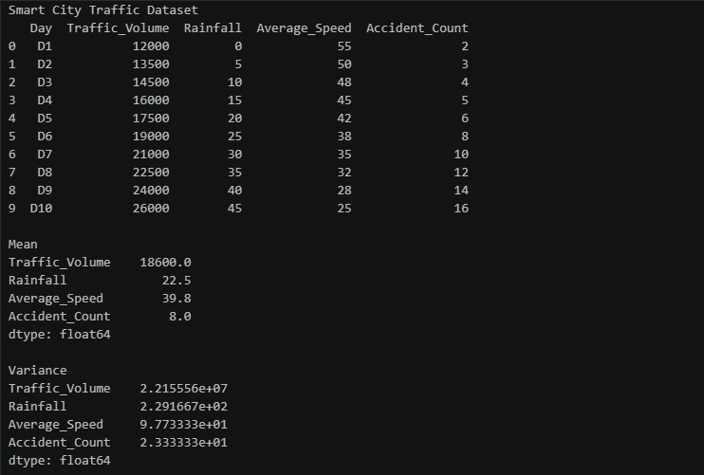
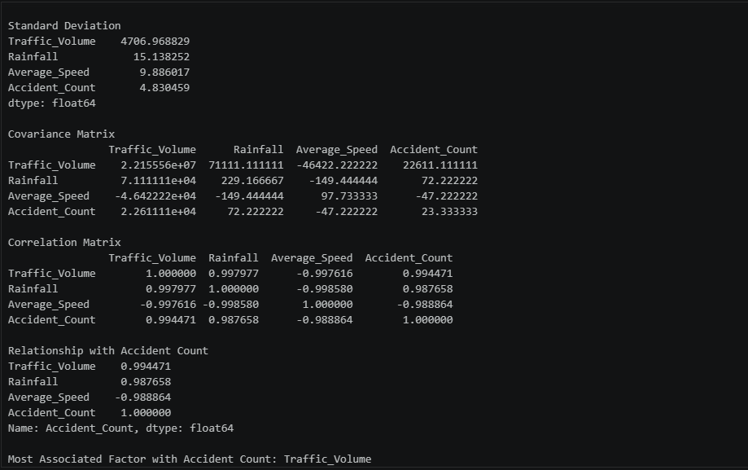
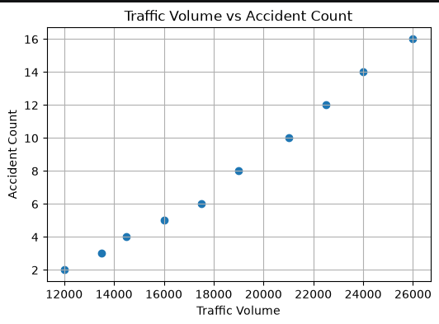
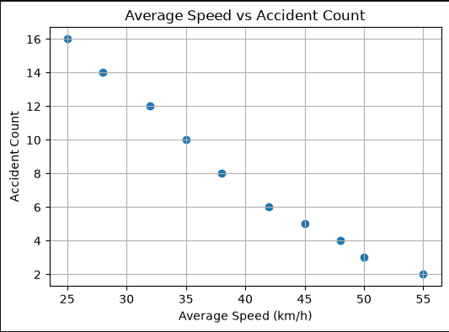
Problem 5: Average Delivery Time
A food delivery company records the delivery times (minutes) for 15 orders: 22, 25, 18, 30, 27, 24, 21, 19, 26, 23, 28, 20, 24, 25, 22
Tasks:
1. Find the point estimate of the population mean delivery time.
2. Find the point estimate of the population variance.
3. Interpret the estimates.
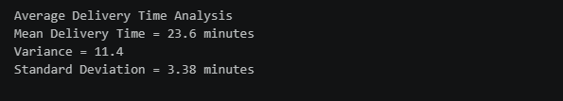
Problem 6: Customer Spending
A sample of 12 customers spent the following amounts ($):
120, 145, 130, 155, 160, 125, 140, 135, 150, 170, 165, 155
Tasks:
1. Estimate the average spending.
2. Estimate the standard deviation.
3. Explain why these are point estimates.

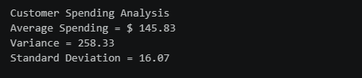
Problem 7: Product Ratings
A company collects ratings from 20 customers:
4, 5, 3, 4, 5, 4, 3, 5, 4, 4, 5, 3, 4, 5, 4, 3, 5, 4, 5, 4
Tasks:
1. Compute the sample mean.
2. Compute the sample variance.
3. Compute the standard error of the mean.
4. Explain what the standard error indicates.
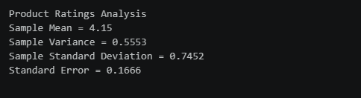
Problem 8: Exam Scores
Scores of 25 students:
72, 75, 68, 80, 77, 73, 79, 81, 76, 74, 78, 69, 70, 82, 71, 75, 77, 73, 80, 76, 74, 79, 72, 81, 78 Tasks:
1. Calculate mean and standard deviation.
2. Calculate standard error.
3. Compare standard deviation and standard error.
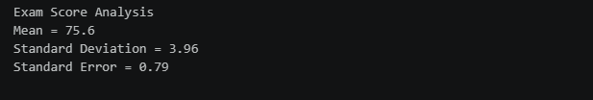

Problem 9: Manufacturing Weights
A sample of 50 packets has:
• Mean weight = 498 g
• Standard deviation = 12 g
Tasks:
1. Construct a 95% confidence interval for the population mean weight. 2. Interpret the interval.
3. Determine whether the target weight of 500 g is plausible.

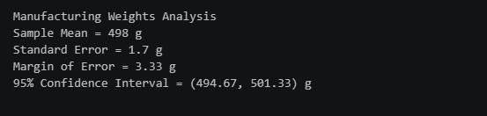

Problem 10: Customer Satisfaction
Two branches report:
Branch Mean Rating 95% CI
A 4.3 (4.1, 4.5)
B 4.0 (3.8, 4.2)
Tasks:
1. Compare the confidence intervals.
2. Can you conclude Branch A performs better?
3. Explain your reasoning.
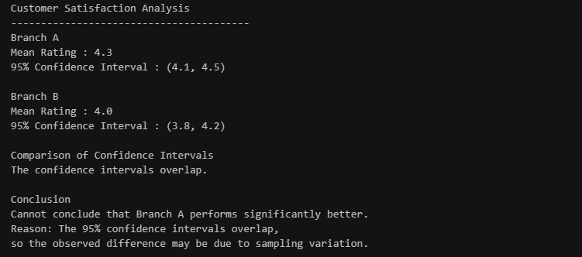

Problem 11: Average Battery Life
A battery manufacturer claims the average battery life is 10 hours. A sample of 36 batteries gives:
• Mean = 9.5 hours
• Standard deviation = 1.8 hours
Tasks:
1. Formulate null and alternative hypotheses.
2. Conduct a hypothesis test at α = 0.05.
3. State your conclusion.

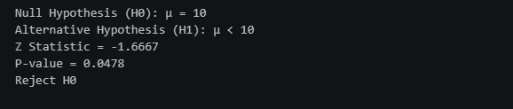
Problem 12: Marketing Campaign
A company believes a new campaign increases sales. Sales before campaign:
50, 52, 49, 55, 53, 51, 54, 50
Sales after campaign:
58, 60, 57, 62, 59, 61, 63, 58
Tasks:
1. Conduct a hypothesis test.
2. Calculate the p-value.
3. Interpret the p-value.
4. Make a decision at α = 0.05.
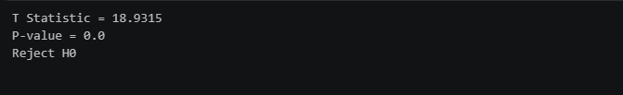
Problem 13: Call Centre Response Time
A sample of 100 calls has:
• Mean response time = 4.8 minutes
• Standard deviation = 1.5 minutes
Tasks:
1. Estimate the population mean.
2. Construct a 95% confidence interval.
3. Explain the Frequentist interpretation.

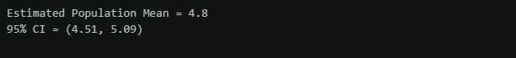
Problem 14: Defective Products
A sample of 500 products contains 22 defective items.
Tasks:
1. Estimate the defect rate.
2. Construct a 95% confidence interval.
3. Explain the Frequentist meaning of the interval.
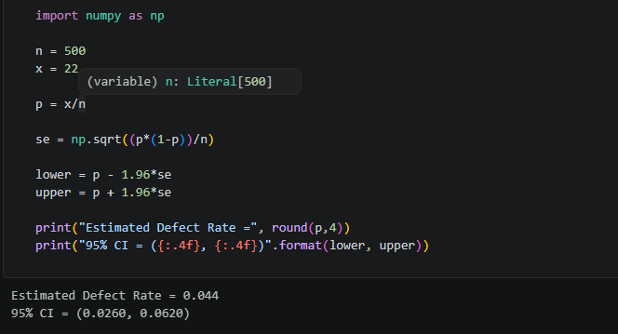
Problem 15: Email Spam Detection
Historical information:
• Probability an email is spam = 0.25
• Probability spam email contains keyword "Offer" = 0.80 • Probability non-spam email contains keyword "Offer" = 0.10
Tasks:
1. Compute the probability that an email is spam given it contains "Offer." 2. Apply Bayes' theorem.
3. Interpret the result.
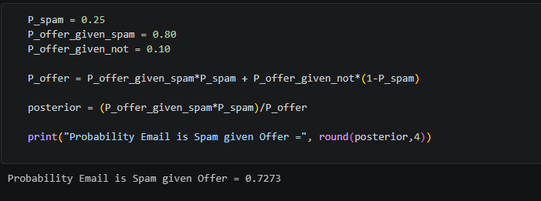
Problem 16: Disease Diagnosis
Given:
• Disease prevalence = 2%
• Test sensitivity = 95%
• Test specificity = 90%
Tasks:
1. Compute the posterior probability of disease after a positive test. 2. Explain why the result differs from 95%.
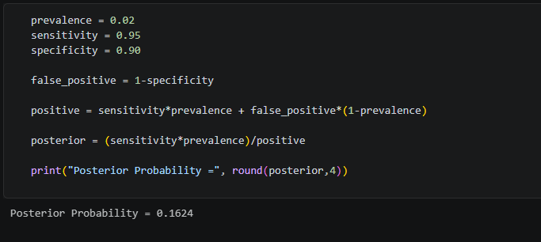
Problem 17: Website Conversion Rate
A company tests two landing pages.
Group Visitors Purchases
A 5000 250
B 5200 312
Tasks:
1. Calculate conversion rates.
2. Formulate hypotheses.
3. Conduct a two-proportion z-test.
4. Determine whether page B performs better.
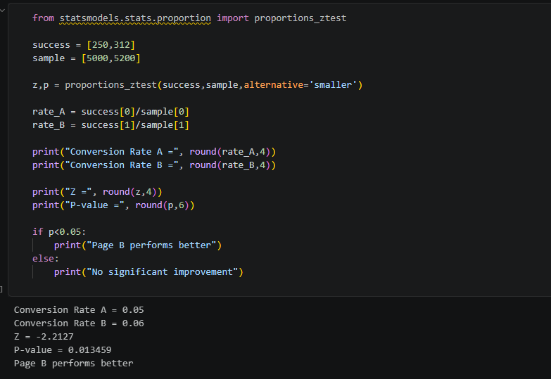
Problem 18: Mobile App Feature Test
Feature A:
• 400 users
• Average engagement = 18 min
• SD = 5 min
Feature B:
• 420 users
• Average engagement = 20 min
• SD = 6 min
Tasks:
1. Test whether Feature B increases engagement.
2. Calculate test statistic and p-value.
3. Interpret results.
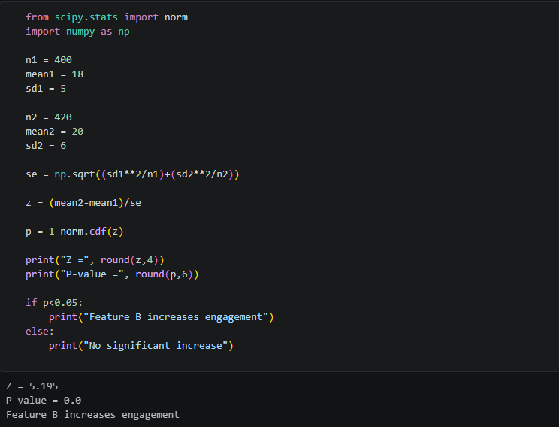

Problem 19: Recommendation System
A new recommendation algorithm increases click-through rate from 4.8% to 5.3%. Sample size:
• Old system: 100,000 users
• New system: 100,000 users
Tasks:
1. Test statistical significance.
2. Calculate p-value.
3. Discuss practical significance versus statistical significance.
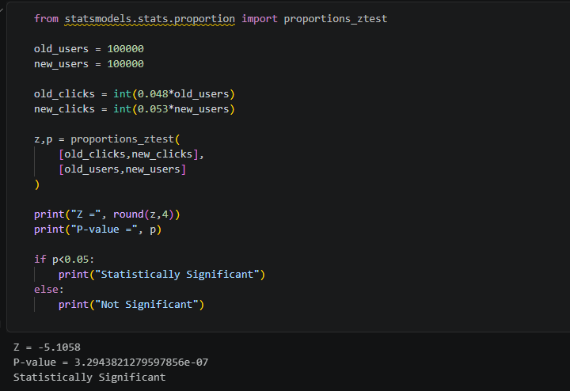

Problem 20: Salary Prediction Model
Two machine learning models produce Mean Absolute Errors (MAE): Model MAE
Model A 4200
Model B 4000
Across 50 test folds, the difference in MAE has:
• Mean difference = 200
• Standard deviation = 350
Tasks:
1. Perform a paired t-test.
2. Determine whether Model B significantly outperforms Model A.
3. Explain the result in terms of statistical significance.
